ANKLE REHAB

Ankle range-of-motion  Dorsiflexion  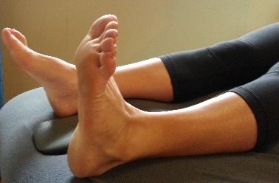  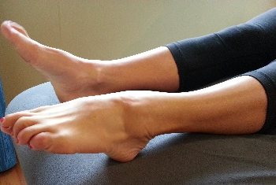  Plantarflexion  Progression:-  - Ankle alphabets | Start position: Lying with leg out straight  - Dorsiflexion: pull toes and ankle up towards you  - Plantarflexion: point toes and ankle down  - Ankle alphabets: move ankle and toes, making an outline of all the letters in the alphabet.  - Ensure working within a painfree range
Theraband  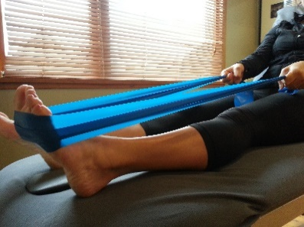  Plantarflexion  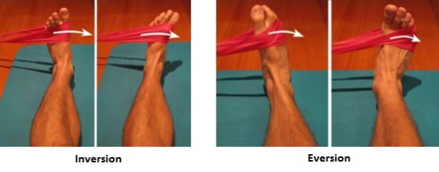 | - Plantarflexion:-  - Place theraband around ball of foot and hold both ends  - Point toes and ankle down by pushing into band  - Slowly allow foot to return to neutral positon in a controlled manner  - Sets: 3 Reps 10-15x  - Inversion:  - Place theraband around ball of foot and tie ends around table leg  - Slowly move your foot and ankle inwards against the band  - Slowly allow foot to return to neutral positon in a controlled manner  - Sets: 3 Reps 10-15x  Eversion:  - Place theraband around ball of foot and tie ends around table leg  - Slowly move your foot and ankle outwards against the band  - Slowly allow foot to return to neutral positon in a controlled manner  - Sets: 3 Reps 10-15x

Single leg balance  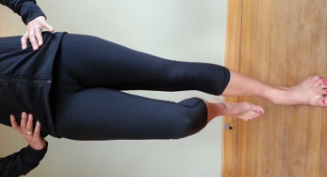 | Start position: standing on injured leg  - Lift uninjured leg & balance on one leg  - Ensure hips are aligned/neutral.  - Hold for 30 seconds.  Tip: maintain equal height of both hips  Try to perform when brushing teeth or waiting for kettle to boil!
Singe leg balance – uneven surface  Progression:-  - Try closing eyes | Start position: standing on injured leg  - Lift uninjured leg & balance on one leg  - Ensure hips are aligned/neutral.  - Aim for a 30 sec hold  Tip: maintain equal height of both hips
Wall squat  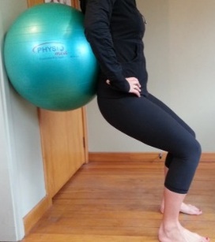 | Start position: Standing, leaning against a ball just below the shoulder blades, up against a wall  - Feet shoulder/hip width apart, feet slightly turned out.  - Lower buttocks as if to sit on a chair.  - Ensure knees track over 2nd toe.  Tip: weight should be evenly distributed between both feet.
Partial squat (approx 45°)  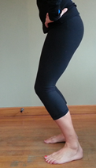  Progressions:-  I – Full squat (approx 90°)  II – Wide squats | Start position: standing, feet hip distance apart  - Feet shoulder/hip width apart, feet slightly turned out.  - Lower buttocks as if to sit on a chair.  - Ensure knees track over 2nd toe.  Tip: weight should be evenly distributed through both heels.
Lunge  Progression:-  - Walking lunge | Start position: injured knee in front. Feet shoulder width apart & long stride  - Lower back knee towards the ground.  - Ensure front knee tracks 2nd toe & does not move over the front of the toes.  - Slowly return to start position.  - Ensure body stays upright when lifting & lowering.
Single leg squat | Start position: standing on injured leg  - Bend knee towards the ground.  - Ensure front knee tracks 2nd toe.  - Slowly straighten knee.
Calf raises  Progressions:-  I – Up: bilat/Down: single (injured)  II – Up & Down: single leg | Start position: standing on step  - Feet shoulder/hip width apart.  - Raise the heel off the floor & balance on the balls of the feet.
Calf stretch – long (gastroc) | Start position: standing, step one leg behind you, knee straight. Make sure your toes are pointing straight forwards  - Keep the back knee straight, lunge forwards onto the front leg until a stretch is felt in the back leg  - Hold for 30 seconds  - Reps: 3x
Calf stretch – short (soleus) | Start position: standing, feet stepped in a pyramid position. Make sure your toes are pointing straight forwards  - Bend the back knee slightly, until a stretch is felt in the back leg  - Hold for 30 seconds  - Reps: 3x

