The Pilates Rest Position
In the rest position your muscles are relaxed and your joints are in neutral alignment. You should try to incorporate the key points of the rest position into all postures throughout your day.

- Lie on your back with your knees bent up and you head supported on a small cushion or folded towel
- Relax the weight of your head into the support
- Lengthen the back of the neck by reaching the crown of the head towards the wall behind you
- Gently draw your shoulder blades down towards your waist to relax the neck and shoulders
- Soften the ribcage into the mat to connect the back of the ribcage on the mat
- Place your feet and knees hip distance apart
- Make sure that your weight rests on the six key points of the feet: the base of each big toes, each little toe and the centre of the heel on each foot

Finding Neutral Spine
Imagine your pelvis is a bucket of water. Tip it backwards to spill some water out the back of the bucket and you will feel your back gently flatten onto the mat. Now tip it forwards to spill some water out of the front of the bucket and you will feel your lower back arch slightly.

- Find your ‘neutral spine’ position by resting the bucket halfway between these two movements. There should be a small space between your back and the mat, and your pubic and hip bones should form a small flat triangle
- Now gently draw you lower abdominals in by drawing your belly button towards your spine- this activates your Transversus Abdominus muscle
- See if you can hold for 5x10seconds
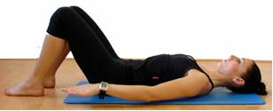
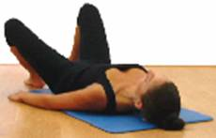  BENT KNEE FALL OUT | Starting position: Rest position  - INHALE to prepare and draw in abdominals  - EXHALE, roll your left leg outwards from your body  - INHALE, roll your left leg back inwards until your left your knee is in line with the left hip  - Repeat alternating legs  - Sets: 2 Reps: 10x
SINGLE LEG LIFTS  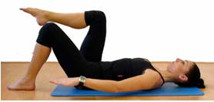 | Starting position: Rest position  - INHALE to prepare and draw in abdominals  - EXHALE, float your right knee over your right hip to assume the ‘tabletop’ leg position  - INHALE lower to the floor  - Alternate legs  - Sets: 2 Reps: 10x each leg  Progressions:  - Lift up right leg then left to table top  - Lower right leg then left to floor  - Sets: 2 Reps: 5x leading right leg then 5x leading left leg
SHOULDER BRIDGE  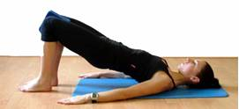 | Starting position: Rest position  - INHALE to prepare and draw in abdominals  - EXHALE, gently roll your lower back into mat, scoop your tailbone upwards and continue to peel your spine off the mat, bone by bone until you are resting on your shoulder blades  - INHALE and hold the shoulder bridge position  - EXHALE, lower the shoulder bridge by lowering one bone at a time to the mat, beginning with the highest vertebrae of your bridge and finishing with your tailbone to return to neutral position. On rolling to the floor think about pulling your bottom ribs down to ensure a smooth roll to the floor  - Sets: 2 Reps: 10x  Progression:  - Engage right glute and hamstring and lift up left foot  - Engage left side and lift right in marching format  - Don't let the pelvis drop
CLAMS | Starting position: sidelying  - INHALE to prepare and draw in abdominals  - EXHALE, lift the top knee upwards keeping the feet together  - INHALE, lower the top knee onto the bottom leg  - Sets: 2 Reps: 10x
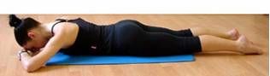  SINGLE LEG KICK | Starting position: Lie on front.  Legs out straight, hip-distance apart. Arms folded, with your forehead resting on the back of the hands. Neck is long.  - INHALE to prepare, draw in abdominals  - EXHALE, bend your left knee, whilst maintaining a neutral spine throughout  - INHALE, extend your knee and lower your leg to the mat  - Alternate legs  - Sets: 2 Reps: 10x
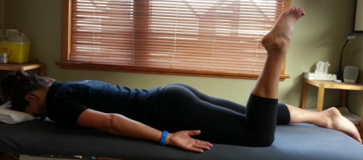  PRONE KNEE BEND | Start position: lying on stomach with forehead supported with a folded towel  - Bend knee, ensuring a neutral spine.  - Lift thigh 1-2cm off the floor by engaging gluts  - Ensure no twisting of the pelvis or lower back  - Hold 5-10 secs then slowly lower thigh

