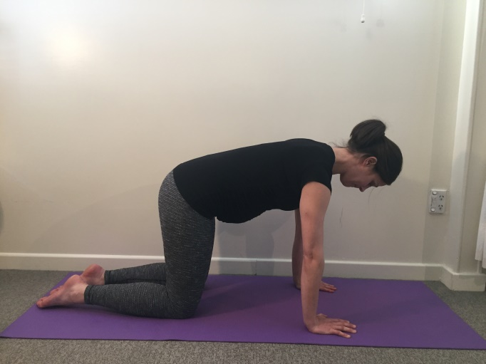
Pelvic tilts
- Position yourself with your hands under your shoulders and knees under your hips.
- Lengthen the back of the neck by reaching the crown of the head towards the wall behind you.
- Gently draw your shoulder blades down towards - your waist to relax the neck and shoulders
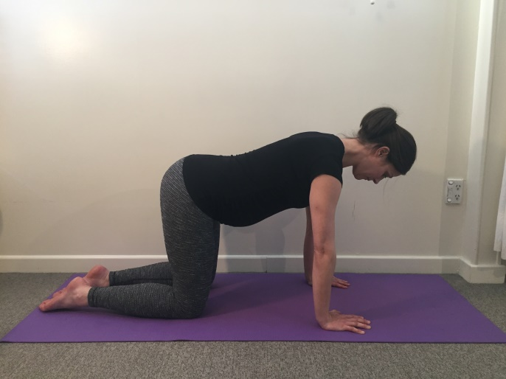
- Imagine your pelvis is a bucket of water. Tip it backwards to spill some water out the back of the bucket and you will feel your back gently flatten.
- Now tip it forwards to spill some water out of the front of the bucket and you will feel your lower back arch slightly.

Finding Neutral Spine
- Find your ‘neutral spine’ position by resting the bucket halfway between these two movements.
- Now gently draw you lower abdominals in by drawing your belly button towards your spine- this activates your Transversus Abdominus muscle
- See if you can hold for 5x10seconds

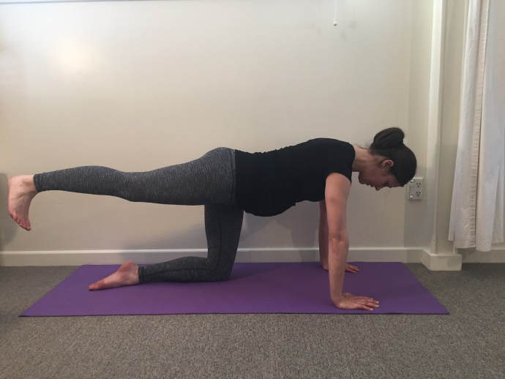

Leg Kicks
- Position as above with neutral spine.
- Whilst maintaining neutral spine, extend a leg out behind you using your buttock muscles and then return to the start position.
- Repeat 2-3x 10 each side

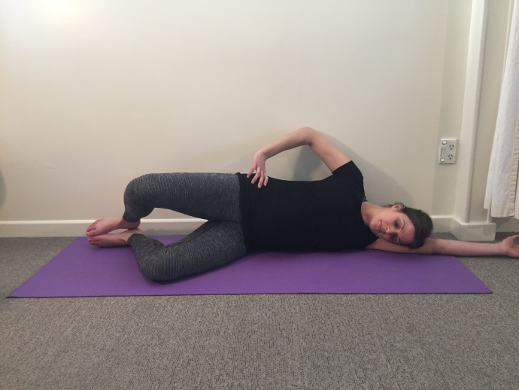
Clams
- Position yourself in side lying with your knees bent to about 90 degrees
- Gently draw your abdominals in.
Slowly open your hip by lifting your knee and keeping your feet together.
- Repeat 2-3x 10 then do other side

Squats
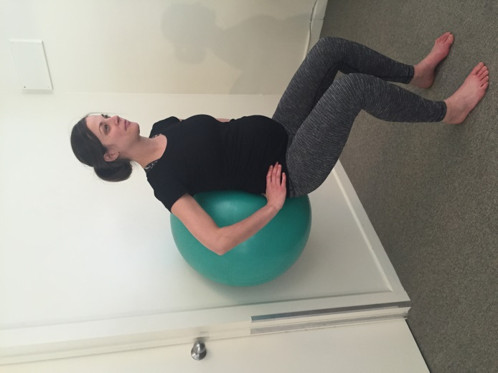
- Position a Swiss ball behind your lower back.
- Draw in abdominals and slowly bend your knees, slowly lowering down.
- Ensure your knees are travelling over your 2nd toes throughout exercise..
- Return to standing
- Repeat 2-3x 10

Variation: Try with a wider stance or add in a hold at the lowest point for 5 seconds.

Rowing
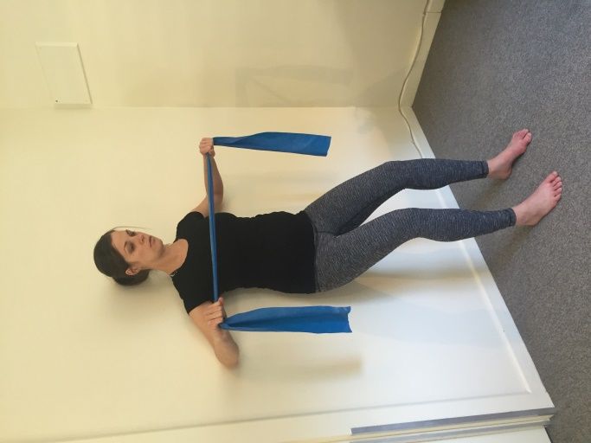
- Using a theraband, start with arms straight out in front of you.
- Draw in abdominals, relax shoulders and bend knees slightly.
- Pull band towards your chest whilst keeping shoulders relaxed.
- Your elbows will widen as they approach the wall, then release.
- Repeat 2-3x 10

Chest Press
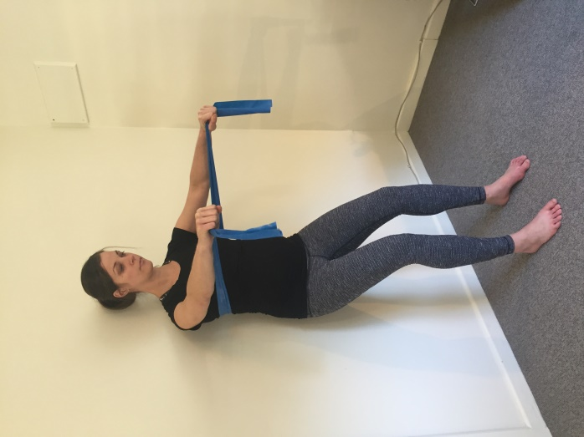
- Position as above but with the band wrapped behind your shoulder blades.
- Draw in your abdominals, relax your shoulders and bend knees slightly.
-Extend your arms out away from you keeping the band at chest height.
- Release tension by returning arms to the start position.
- Repeat 2-3x 10

Please contact us if you are unsure if these exercises are suitable for you. We would be happy to help. We can also provide further progressions to the above to give you a more comprehensive and individualised programme.

